Criminal Justice Policies in New York City
Student’s Name
Instructor’s Name
Date

Criminal Justice Policies in New York City
Criminal justice is the conveyance of justice to those who have committed crimes. Crimes are performed in different ways; however, the criminal justice system needs to devise ways of how to handle such situations when they happen and to prevent them from happening. New York City faces several criminal justice policy challenges, especially in immigration and public shooters. New York City has been experiencing a problem of immigration for many years now, and it is high time that policies to counter the immigration should be put in place. Similarly, the challenge of the public shooter has also been increasing especially in schools, open commercials, and office buildings.
The public shooting is a situation which is dynamic as it may involve individuals attacking the public in different forms; therefore, some attacker may use various means than the others. The policy is a challenge as it consists of a situation where a person or a group of individuals are engaged in a practice of killing or having an attempt to kill other individuals in a place where people are gathered, or the population of people is immense. However, according to the Department of Homeland security, the majority of the public shooters use firearms in their attacks, and there is no format of them selecting the victims for them to attack.
The practice of public shooting has become a significant challenge to New York City because it happens frequently and with no sign of planning. According to The New York City Police Department (NYPD) report, they analyzed the relationship between the victims and the attacker and realized that the attacker always does not have a plan of when to attack and who to attack (Silva & Capellan, 2019). The attack is ever made impetuously; nonetheless, some of the public shooters do have some planning, and they have to perform several surveillances of the areas to attack first. Moreover, some of the public shooters make a preplanned cover to make their targets will not have a way to escape and hence having more victims as possible; for example, attackers may decide to block entrances and chaining doors.
Another challenge New York City face is the increased number of deaths caused by criminal justice. Many people die because of public shooting in the City, while the security department makes it hard to predict the number of injured people in one attack because of the variations of the attack. Similarly, limited attacks may lead to a considerable number of casualties. Furthermore, the time taken to perform an attack is always short, and it can take up to fifteen minutes. Hence the time is too limited to make the security team have arrived; thus, many people will have succumbed to death and the majority being injured. Moreover, attackers always target a location that will have many people to attract many people in the attack.
Consequently, immigration has been happening in New York City for very many years. The development of the City has been made achievable because of the provision of labor from the immigrants. Therefore, immigrants are the process where people move from one country to another country which they are not natives and live there permanently. Many people migrated to New York City from other countries to seek freedom and opportunities in the City (Stott, 2019). Although the immigrants play a crucial role in developing the economy of the City, they also pose a challenge as the majority of the people are not documented. Hence, in case of any crimes done, they will not be identified.
The number of immigrants has been shifting since the year 1970 when the majority of the immigrants were Europeans, and currently, the European percentage has dropped to around fifteen percent (Reitano, 2018). At this time, the immigrants with the majority in numbers are the Asians, the Caribbean, and the Latin Americans. Therefore, on average more than one hundred and fifty nations are presented with no nation-leading. Immigration is good for the City, but the rate at which is available currently is much higher than expected and will probably lead to social division.
The solution to combating the public shooting criminal justice policy is to make the public aware that security starts with an individual. The attackers always use short time to perform their actions and therefore, backup from the security team will not be available on time. Between 8:00 AM and 4:00 AM majority of public shooting occurs, even though all shooting occurred at all times of the day (Apexofficer.com., n.d).
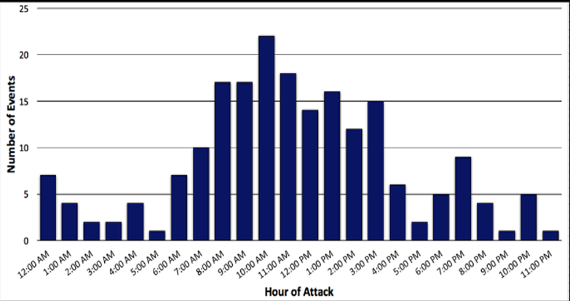
Consequently, people should be prepared both physically and mentally to pact with the situation when it happens. Another way to handle the crime when it happens is to run. However, when running, certain situations occur when a person has an escape route in mind and can utilize it well. Also, the victim should leave irrespective of whether other individuals around are willing to go or not as well as stop other people from going to where the shooter is available. Besides, they should keep their hands in a position where they can be seen to allow the police to know that the person is not a public shooter. The next step a person should take is to hide, an individual under attack should ensure that the shooter does not see, locate a place where they will be safe from the shooter and hide in an area that will not make them hard to move or which will trap them. Individuals are also advised to be aware of their environment, and the dangers that might happen as well as observe and keep in mind exits available in every place or building they visit. Furthermore, individuals should also be able to fight in case there are no other means available, the fight required in such a situation includes acting violently and throwing available items such as books and garbage are to the attacker.
Notably, immigration provides essential aspects when it comes to the development of New York City; however, mentioned challenges make them have policies to deal with the rate of immigration. The solution to the immigration policy in New York City is to provide laws that will control the number the immigrants who come in the City annually as well as the benefits which they should enjoy while in the City. The strategy of making as many immigrants as possible to be documented is working because the city is a home of 560,000 undocumented immigrants indicating a drop with the 2008 population of 618,000 (NYC Mayor's Office of Immigrant Affairs, 2018). Roughly, 54% of immigrants in the city are naturalized United States citizens and other 660,000 immigrants have green cards and hence predicated to be lawful permanent residents.
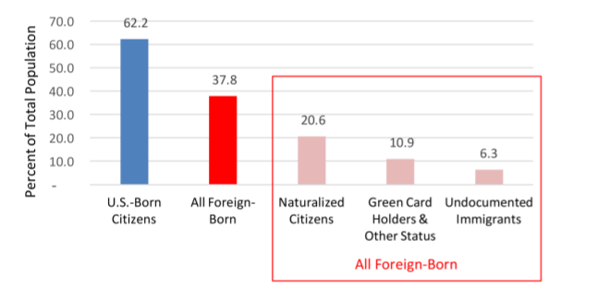

The federal government is responsible for immigrants and the Aliens who reside in New York; therefore they are required to provide requirements for immigrants before they are allowed to enter the City. For example, the process of providing green cards, visas and citizenship should be done with utmost strictness, this will enable reduce chances of crimes as well as tracking individuals who will have involved in a crime. The City should also have regulatory laws regarding employment opportunities, education, and licensing to provide more benefits to the residents of the City as many immigrants bring high competition in such opportunities hence making residents suffer. Moreover, the immigrants have the same rate of partaking labor as residents of the city. Although the undocumented immigrants have a higher rate of 77.3% of labor force, the foreign-born workers have improved from 31% in 1990 to 45% of the city labor force (NYC Mayor's Office of Immigrant Affairs, 2018).
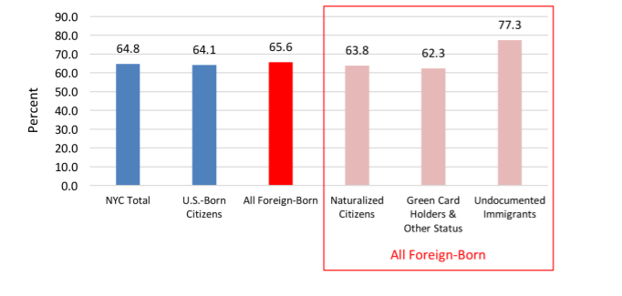
However, there are the majority of the immigrants who are involved in entrepreneurship in the City, they also need to be encouraged as they aid in developing the City as well as growing it economically. An example of regulation stated is for an immigrant to move to the City, they need to have a valid visa, then live in the country for the required time before obtaining a green card. The process will vary based on the type of visa. Then a person will have to fill the correct forms and be moral citizens with no criminal records and learn the history of the country, and the next step will be to wait for approval after passing the person will take an oath.
References
Apexofficer.com. (n.d). ACTIVE SHOOTER AND MASS SHOOTING FACTS. Retrieved from https://www.apexofficer.com/active-shooter-facts
NYC Mayor's Office of Immigrant Affairs. (2018). State of our Immigrant city. MOIA Annual Report.
Reitano, J. (2018). The Restless City: A short history of New York from colonial times to the present. Routledge.
Silva, J. R., & Capellan, J. A. (2019). The media’s coverage of mass public shootings in America: fifty years of newsworthiness. International Journal of Comparative and Applied Criminal Justice, 43(1), 77-97.
Stott, R. B. (2019). Workers in the metropolis: Class, ethnicity, and youth in antebellum New York City. Cornell University Press.

